From: | Tara Ashby <taraashby@yahoo.com>
Sent:  To: | Wednesday, September 30, 2026 9:05 AM sctclerk@mssc.state.ms.us | ORIGINAL
Subject: | Subject: Request for Rehearing/Clarification — Gregg v. State
Attachments: | Supreme Court consideration on parole.pdf
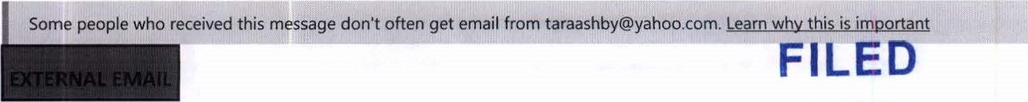
SEP 30 2026
OFFICE OF THE CLERK
Dear Justices, SUPREME COURT
COURT OF APPEALS I am writing as an advocate and family friend of Carly Madison Gregg to respectfully request that the Court consider rehearing, or otherwise clarifying, its August 20, 2026 decision in Gregg v. State, particularly as it relates to Carly's parole eligibility.
I recognize and respect the Court's decision and the legal issues it addressed. My request is focused narrowly on ensuring that Carly's sentence is understood and applied consistent with the Court's determination that her life sentence is not a sentence of life without parole.
Given Carly's age at the time ofthe crimes, the constitutional principles governing juvenile sentencing, and the Court's clarification regarding the nature of her life sentence, I respectfully ask the Court to provide further clarification concerning when and under what circumstances she may become eligible for parole consideration.
My attached letter of request is not intended to minimize the seriousness of the offenses or the unimaginable harm experienced by the victims and their families. Rather, it asks the Court to ensure that Carly's sentence provides the meaningful opportunity for release that distinguishes a life sentence from life without parole for a juvenile offender.
Thank you for your consideration of this request and for the Court's careful attention to this important matter.
Respectfully,
Tara Ashby
570-244-1427
Advocate and Family Friend ofCarly Madison Gregg
"Remind yourself that instead of focusing on what you have to do today, choose to focus on what you get to do today" Landon Ashby
1
Tara Ashby Muncy, Pennsylvania targash by@yahoo.com
September 30, 2026 Sent Vla Email:
The Honorable Justices of the Supreme Court of Mississippi
Supreme Court of Mississippi
450 High Street
Jackson, Mississippi 39201
Re: Carly Madison Gregg — Request for Rehearing and Clarification of Parole Eligibility Case No. 2024-KA-OI 178-SCT
Dear Chief Justice and Honorable Justices of the Mississippi Supreme Court:
My name is Tara Ashby, and I am writing to you as a family friend and advocate for Carly Madison Gregg. I respectfully ask the Court to consider rehearing, or otherwise providing clarification regarding Carly's parole eligibility following the Court's August 20, 2026, decision in Gregg v. State.
I recognize and respect that the Court carefully considered Carlys case and the many legal issues involved. I am not writing to challenge the Courts authority or findings. Rather, I am asking the Court to give practical meaning to one of the most important conclusions in its decision: Carly was sentenced to life imprisonment, not life imprisonment without the possibility ofparole. The distinction is profoundly important.
The Court recognized that Mississippi law did not authorize a sentence of life without parole for a juvenile convicted of first-degree murder under the applicable statute. The Court further recognized that Carly's sentence was life imprisonment and that she is potentially eligible for parole. I respectfully ask the Court to take the next step and specifically identifr the minimum period Carly must serve before becoming eligible for parole consideration, and to direct the Mississippi Department of Corrections to recognize and implement that determination. For Carly and her family, the difference between life imprisonment and life without parole is not simply a legal distinction. It is a difference between having a future opportunity to demonstrate rehabilitation and having no opportunity at all.
I am not asking the Court to order Carlys release, I am asking only that she be given a definite opportunity to someday be considered for release based upon who she becomes, rather than solely who she was at fourteen.
Fourteen is a child, not an adult.
Carly was fourteen years old.
Children do not possess the maturity, judgment, emotional development, or life experience of an adult. Yet that child will continue to grow, learn, mature, and change. If Carly is eventually considered for parole, she will not be the same person who entered the criminal justice system at fourteen. She should have the opportunity to demonstrate who she has become.
Carly has changed my life since I met her. Through her and because of her, I have become an advocate for juveniles who are incarcerated, tried, and sentenced as adults. I have learned how desperately our system needs to recognize the developmental differences between children and adults and to provide appropriate opportunities for rehabilitation. We have a responsibility to protect, teach, and nurture our children, even when they have caused serious harm. Children are capable of change, and our justice system should leave room for that possibility.
A parole-eligible life sentence does not erase accountability. Carly has already been held accountable and has lost years of her childhood, adolescence, and young adulthood to incarceration. If she eventual ly comes before the parole board, she should be evaluated based upon the person she has become, her maturity, rehabilitation, conduct, education, accountability, and ability to live responsibly.
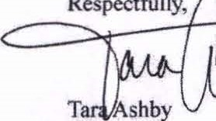T Ashby  Respectfully,  Family Friend  Muncy, Pennsylvania | 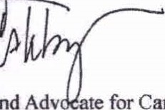te for Carly Madison Gregg  and  Adv
The Court's August 20 decision established that Carly's sentence is life imprisonment, not life without parole. I respectfully ask the Court not to leave that distinction without a practical endpoint.
Please provide a written determination establishing the minimum period Carly must serve before becoming eligible for parole consideration and direct the Mississippi Department of Corrections to recognize and implement that determination. Carly deserves the opportunity to someday demonstrate who she has become.
Thank you for your consideration and for the time and eare the Court has devoted to Carly's case.

